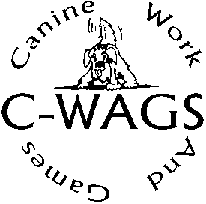Master or Achiever Team Award Application

|  |  |
| --- | --- |
| **Team Registration Number**: | Date: |
| Dog: | |
| Handler: | |
| Address: | |
| City, State, Zip: | |
| Email: | |

Please indicate below the Master Team Award you are applying for by circling at least 3 Ace titles (of the 4 different programs) you currently have earned in a single level. Enter the dates, if known.

|  |  |  |  |
| --- | --- | --- | --- |
| ***Master Team Award Level 1*** | ***Master Team Award Level 2*** | ***Master Team Award Level 3*** | ***Master Team Award Level 4*** |
| Obedience Ace  Level 1  Date: | Obedience Ace  Level 2  Date: | Obedience Ace  Level 3  Date: | Obedience Ace  Level 4  Date: |
| Starter or Zoom 1 Rally Ace  Date: | Advanced or Zoom 1.5 Rally Ace  Date: | Pro or Zoom 2  Rally Ace  Date: | ARF Ace  Date: |
| Games  Level 1 Ace  Date: | Games  Level 2 Ace  Date: | Games  Level 3 Ace  Date: | Games  Level 4 ACE  Date: |
| Any Scent Level 1 Ace  Date: | Any Scent Level 2 Ace  Date: | Any Scent Level 3 Ace  Date: | Any Scent Level 4 Ace  Date: |

**Scent Achiever Team Award:** Application for this award may be made upon completion of ACE titles in each series of scent classes (Detective, Ranger, and Dasher) at the same level.

|  |  |
| --- | --- |
| ***Achiever Team Award 4*** | ***Achiever Team Award 5*** |
| Super Sleuth 4  Date: | Private Inv. Or Det. Diversions  Date: |
| Ranger 4  Date: | Ranger 5  Date: |
| Dasher 4  Date: | Dasher 5  Date: |

Thank you for supporting and playing with C-WAGS!

Submit by email to: [c-wags@sbcglobal.net](mailto:c-wags@sbcglobal.net?subject=Master%20Team%20Application)

or mail to

C-WAGS

℅ Shirley Ottmer

3693 Fairview Ave

Jackson, MI 49203